**Methods for Handling Deadlocks**

Generally speaking, we can deal with the deadlock problem in one of three ways:

• We can use a protocol to prevent or avoid deadlocks, ensuring that the system will never enter a deadlocked state.

• We can allow the system to enter a deadlocked state, detect it, and recover.

• We can ignore the problem altogether and pretend that deadlocks never occur in the system.

The third solution is the one used by most operating systems, including Linux and Windows. It is then up to the application developer to write programs that handle deadlocks.

To ensure that deadlocks never occur, the system can use either a deadlock-prevention or a deadlock avoidance scheme. Deadlock prevention provides a set of methods to ensure that at least one of the necessary conditions cannot hold. These methods prevent deadlocks by constraining how requests for resources can be made.

Deadlock avoidance requires that the operating system be given additional information in advance concerning which resources a process will request and use during its lifetime. With this additional knowledge, the operating system can decide for each request whether or not the process should wait. To decide whether the current request can be satisfied or must be delayed, the system must consider the resources currently available, the resources currently allocated to each process, and the future requests and releases of each process.

If a system does not employ either a deadlock-prevention or a deadlock-avoidance algorithm, then a deadlock situation may arise. In this environment, the system can provide an algorithm that examines the state of the system to determine whether a deadlock has occurred and an algorithm to recover from the deadlock.

**Deadlock Prevention**

For a deadlock to occur, each of the four necessary conditions must hold. By ensuring that at least one of these conditions cannot hold, we can prevent the occurrence of a deadlock. We elaborate on this approach by examining each of the four necessary conditions separately.

**Mutual Exclusion**

The mutual exclusion condition must hold. That is, at least one resource must be non-sharable. Sharable resources, in contrast, do not require mutually exclusive access and thus cannot be involved in a deadlock. Read-only files are a good example of a sharable resource. If several processes attempt to open a read-only file at the same time, they can be granted simultaneous access to the file. A process never needs to wait for a sharable resource. In general, however, we cannot prevent deadlocks by denying the mutual-exclusion condition, because some resources are intrinsically non-sharable. For example, a mutex lock cannot be simultaneously shared by several processes.

**Hold and Wait**

To ensure that the hold-and-wait condition never occurs in the system, we must guarantee that, whenever a process requests a resource, it does not hold any other resources. One protocol that we can use requires each process to request and be allocated all its resources before it begins execution. We can implement this provision by requiring that system calls requesting resources for a process precede all other system calls.

**No Preemption**

The third necessary condition for deadlocks is that there be no pre-emption of resources that have already been allocated. To ensure that this condition does not hold, we can use the following protocol. If a process is holding some resources and requests another resource that cannot be immediately allocated to it (that is, the process must wait), then all resources the process is currently holding are preempted. In other words, these resources are implicitly released. The preempted resources are added to the list of resources for which the process is waiting. The process will be restarted only when it can regain its old resources, as well as the new ones that it is requesting.

Alternatively, if a process requests some resources, we first check whether they are available. If they are, we allocate them. If they are not, we check whether they are allocated to some other process that is waiting for additional resources. If so, we preempt the desired resources from the waiting process and allocate them to the requesting process. If the resources are neither available nor held by a waiting process, the requesting process must wait. While it is waiting, some of its resources may be preempted, but only if another process requests them. A process can be restarted only when it is allocated the new resources it is requesting and recovers any resources that were pre-empted while it was waiting.

**Circular Wait**

The fourth and final condition for deadlocks is the circular-wait condition. One way to ensure that this condition never holds is to impose a total ordering of all resource types and to require that each process requests resources in an increasing order of enumeration.

Note also that if several instances of the same resource type are needed, a single request for all of them must be issued.

To illustrate, we let R = {R1, R2, ...,Rm } be the set of resource types. We assign to each resource type a unique integer number, which allows us to compare two resources and to determine whether one precedes another in our ordering. Formally, we define a one-to-one function F: R →N, where N is the set of natural numbers. For example, if the set of resource types R includes tape drives, disk drives, and printers, then the function F might be defined as follows:

F (tape drive) = 1

F (disk drive) = 5

F (printer) = 12

We can now consider the following protocol to prevent deadlocks: Each process can request resources only in an increasing order of enumeration. That is, a process can initially request any number of instances of a resource type —say, Ri. After that, the process can request instances of resource type R j If and only if F(Rj)>F(Ri). For example, using the function defined previously, a process that wants to use the tape drive and printer at the same time must first request the tape drive and then request the printer.

**Deadlock Avoidance**

Deadlock-prevention, prevent deadlocks by limiting how requests can be made. The limits ensure that at least one of the necessary conditions for deadlock cannot occur. Possible side effects of preventing deadlocks by this method, however, are low device utilization and reduced system throughput.

An alternative method for avoiding deadlocks is to require additional information about how resources are to be requested. For example, in a system with one tape drive and one printer, the system might need to know that process P will request first the tape drive and then the printer before releasing both resources, whereas process Q will request first the printer and then the tape drive. With this knowledge of the complete sequence of requests and releases for each process, the system can decide for each request whether or not the process should wait in order to avoid a possible future deadlock. Each request requires that in making this decision the system consider the resources currently available, the resources currently allocated to each process, and the future requests and releases of each process.

The simplest and most useful model requires that each process declare the maximum number of resources of each type that it may need. Given this a priori information, it is possible to construct an algorithm that ensures that the system will never enter a deadlocked state. A deadlock-avoidance algorithm dynamically examines the resource-allocation state to ensure that a circular-wait condition can never exist. The resource-allocation state is defined by the number of available and allocated resources and the maximum demands of the processes.

**Safe State**

A state is safe if the system can allocate resources to each process (up to its maximum) in some order and still avoid a deadlock. More formally, a system is in a safe state only if there exists a safe sequence.

A sequence of processes < P1,P2,...,Pn> is a safe sequence for the current allocation state if, for each Pi , the resource requests that Pi can still make can be satisfied by the currently available resources plus the resources held by all Pj ,with j < i. In this situation, if the resources that Pi needs are not immediately available, then Pi can wait until all Pj have finished. When they have finished, Pi can obtain all of its needed resources, complete its designated task, return its allocated resources, and terminate. When Pi terminates, Pi +1 can obtain its needed resources, and so on. If no such sequence exists, then the system state is said to be unsafe.

To illustrate, we consider a system with twelve magnetic tape drives and three processes: P0, P1, and P2. Process P0 requires ten tape drives, process P1 may need as many as four tape drives, and process P2 may need up to nine tape drives. Suppose that, at time t0 , process P0 is holding five tape drives, process P1 is holding two tape drives, and process P2 is holding two tape drives. (Thus, there are three free tape drives.)

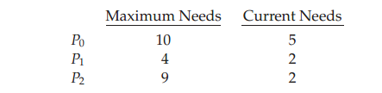

At time t0, the system is in a safe state. The sequence <P1, P0, P2 > satisfies the safety condition. Process P1 can immediately be allocated all its tape drives and then return them (the system will then have five available tape drives);

A system can go from a safe state to an unsafe state. Suppose that, at time t1, process P2 requests and is allocated one more tape drive. The system is no longer in a safe state. At this point, only process P1 can be allocated all its tape drives. When it returns them, the system will have only four available tape drives. Since processP0 is allocated five tape drives but has a maximum of ten, it may request five more tape drives. If it does so, it will have to wait, because they are unavailable. Similarly, process P2 may request six additional tape drives and have to wait, resulting in a deadlock. Our mistake was in granting the request from process P2 for one more tape drive. If we had made P2 wait until either of the other processes had finished and released its resources, then we could have avoided the deadlock.

Given the concept of a safe state, we can define avoidance algorithms that ensure that the system will never deadlock. The idea is simply to ensure that the system will always remain in a safe state. Initially, the system is in a safe state. Whenever a process requests a resource that is currently available, the system must decide whether the resource can be allocated immediately or whether the process must wait. The request is granted only if the allocation leaves the system in a safe state.

**Resource-Allocation-Graph Algorithm**

If we have a resource-allocation system with only one instance of each resource type, we can use a variant of the resource-allocation graph for deadlock avoidance. In addition to the request and assignment edges already described, we introduce a new type of edge, called a claim edge. A claim edge Pi →Rj indicates that process Pi may request resource Rj at some time in the future. This edge resembles a request edge in direction but is represented in the graph by a dashed line.

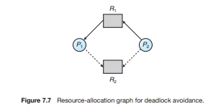

**Exercise**

**Q1)** A system has five processes P1 through P5 and four resource types R1 through R4.

There are 2 units of each resource type. Given that:

P1 holds 1 unit of R1 and requests 1 unit of R4

P2 holds 1 unit of R3 and requests 1 unit of R2

P3 holds one unit of R2 and requests 1 unit of R3

P4 requests 1 unit of R4

P5 holds one unit of R3 and 1 unit of R2, and requests 1 unit of R3

Show the resource graph for this state of the system. Is the system in deadlock, and if so, which processes are involved?

Ans.

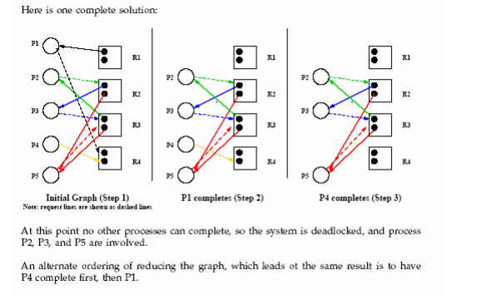

**Q2)** A system has four processes P1 through P4 and two resource types R1 and R2.

It has 2 units of R1 and 3 units of R2.

Given that:

P1 requests 2 units of R2 and 1 unit of R1

P2 holds 2 units of R1 and 1 unit of R2

P3 holds 1 unit of R2

P4 requests 1 unit of R1

Show the resource graph for this state of the system. Is the system in deadlock, and if so, which processes are involved?

Ans.

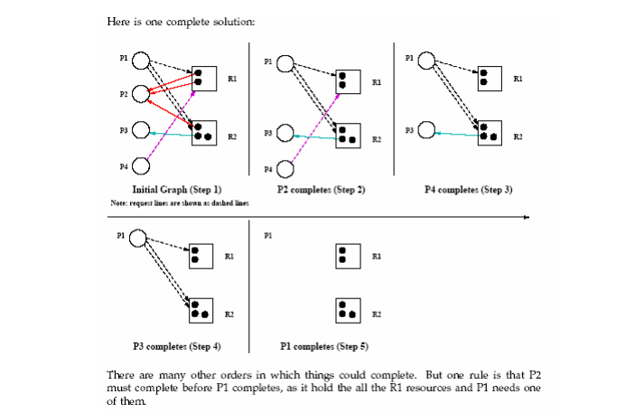

**Q3)** Given a total of 10 units of a resource type, and given the safe state shown below, should process P2 be granted a request of 2 additional resources?

Process Used Max

P1 2 5

P2 1 6

P3 2 6

P4 1 2

P5 1 4

Ans.

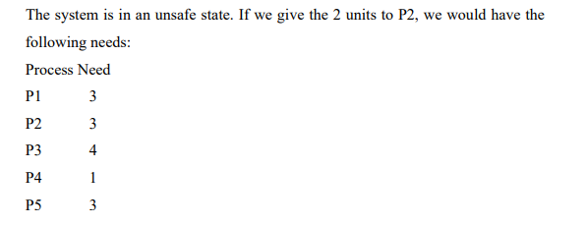

We have 1 unit left, which we can give to P4, which will release only 2 units. Of the processes remaining, no process can complete with only 2 units, so the system is unsafe.

Video Links: <https://www.youtube.com/watch?v=qkMDpzZuTkA>

<https://www.youtube.com/watch?v=YeXS1JWIA4Q>

REFERENCES:

1. Galvin, Peter B., Silberchatz, A., “*Operating System Concepts*”, Addison Wesley, 8th Edition.
2. Flynn, *“Operating Systems”*, Cengage Learning.
3. Dhamdhere, D.M., "*Operating System:A Concept Based Approach*",  
   Tata Mc-Graw- Hill.
4. https://ocw.mit.edu/courses/electrical-engineering-and-computer-science/6-828-operating-system-engineering-fall-2012/lecture-notes-and-readings/
5. **https://www.youtube.com/watch?v=8ZS7xzWPo5A&list=PL3-wYxbt4yCjpcfUDz-TgD_ainZ2K3MUZ&index=33**
6. <https://computing.llnl.gov/tutorials/>
7. https://nptel.ac.in/courses/106/105/106105214
8. <https://www.guru99.com/operating-system-tutorial.html>
9. <https://www.geeksforgeeks.org/operating-systems/>